**Lab No 9**

**Name : Muhammad Faizan Reg. No. : 21-NTU-CS-1258**

**(Q1)**

#include<iostream>

using namespace std;

int main()

{

char arr[300]={"The most likely way for the world to be destroyed,\n Most experts agree, \‘is by accident’.\n That\’s where we come in;\n\“We\’re computer professionals. We cause accidents.”"};

cout<<arr<<endl;

}

**Output**

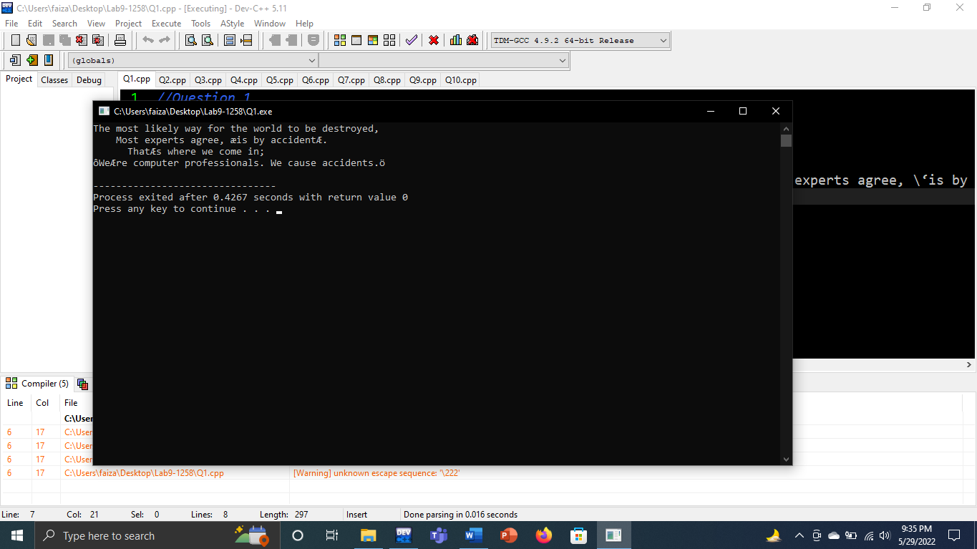

**(Q2)**

#include<iostream>

using namespace std;

int main()

{

char arr[300]={"The most likely way for the world to be destroyed,\n Most experts agree, \‘is by accident’.\n That\’s where we come in;\n\“We\’re computer professionals. We cause accidents.”"};

int count;

for(int i=0;arr[i]!='\0';i++)

{

if (arr[i]=='a'||arr[i]=='e'||arr[i]=='i'||arr[i]=='o'||arr[i]=='u')

{

count++;

}

}

cout<<"No of vovels are "<<count;

}

**Output**

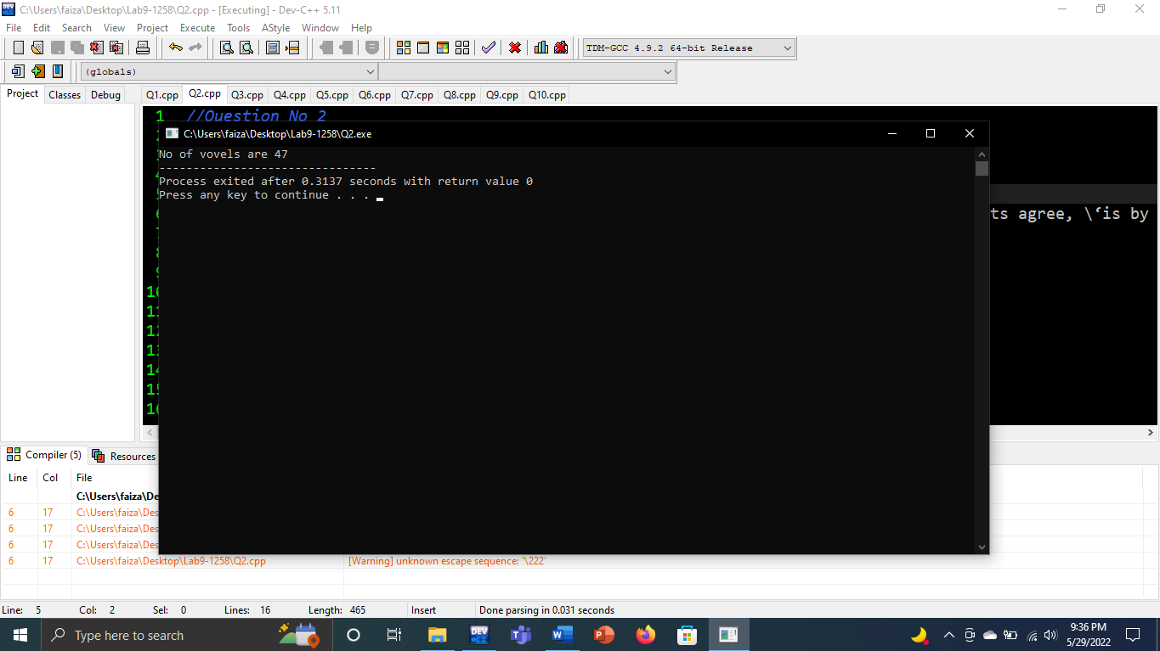

**(Q3)**

#include<iostream>

using namespace std;

int main()

{

char arr[200];

cout<<"Enter the array ";

gets(arr);

cout<<endl;

cout<<"Characters are\n"<<arr<<endl;

}

**Output**

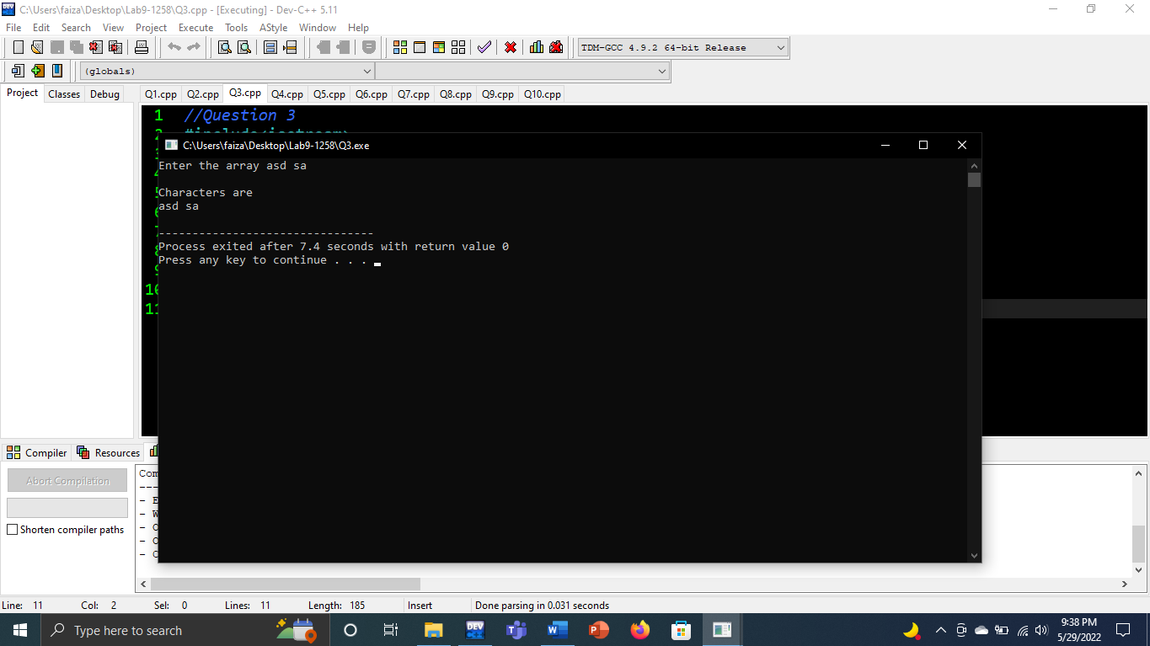

**(Q4)**

#include<iostream>

using namespace std;

int main()

{

char arr[1000]={"Save the following string in an array and display it on screen exactly in the same manner:The most likely way for the world to be destroyed,\n Most experts agree, \‘is by accident’.\n That\’s where we come in;\n\“We\’re computer professionals. We cause accidents.” Count how many vowels are in the above string"};

int count,cons;

for(int i=0;arr[i]!='\0';i++)

{

if (arr[i]=='a'||arr[i]=='e'||arr[i]=='i'||arr[i]=='o'||arr[i]=='u')

{

count++;

}

else

{

cons++;

}

}

cout<<"No. of vovels are "<<count<<endl;

cout<<"No. of consonents are "<<cons;

}

**Output**

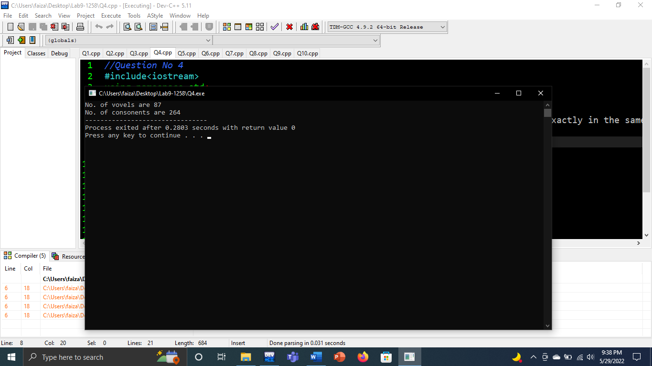

**(Q5)**

#include<iostream>

using namespace std;

int main()

{

char arr[200];

cout<<"Enter characters without spaces ";

gets(arr);

int count=0;

for(int i=0;arr[i]!='\0';i++)

{

if(arr[i]==' ')

{

}

else

{

count++;

}

}

cout<<"No of characters are "<<count;

}

**Output**

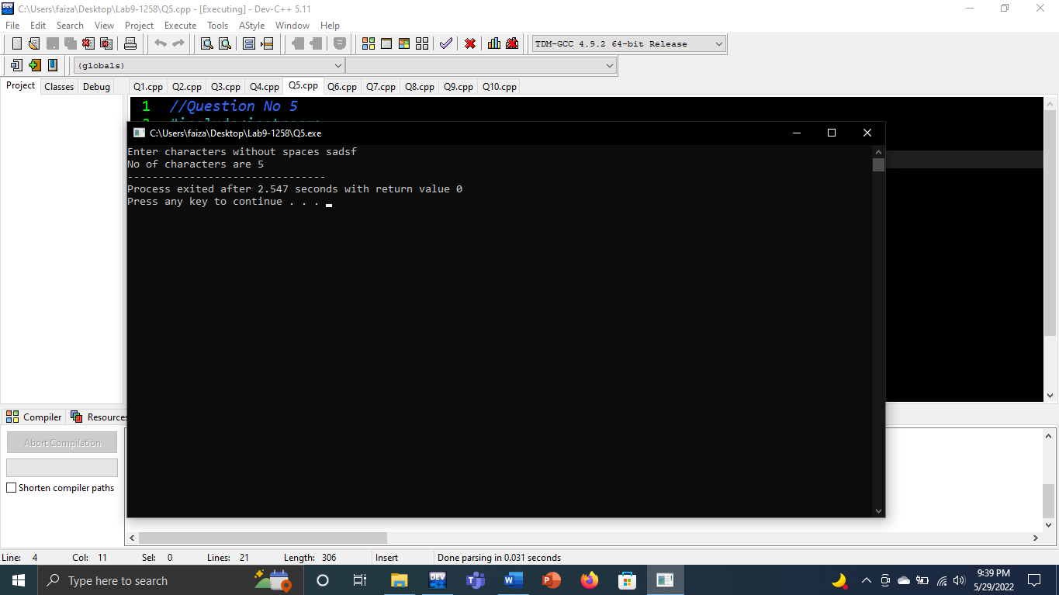

**(Q6)**

#include<iostream>

using namespace std;

int main()

{

char arr[100];

cout<<"Enter String ";

gets(arr);

for(int i=0;arr[i]!='\0';i++)

{

if(arr[i]==' ')

{

arr[i]='\t';

}

}

cout<<arr;

}

**Output**

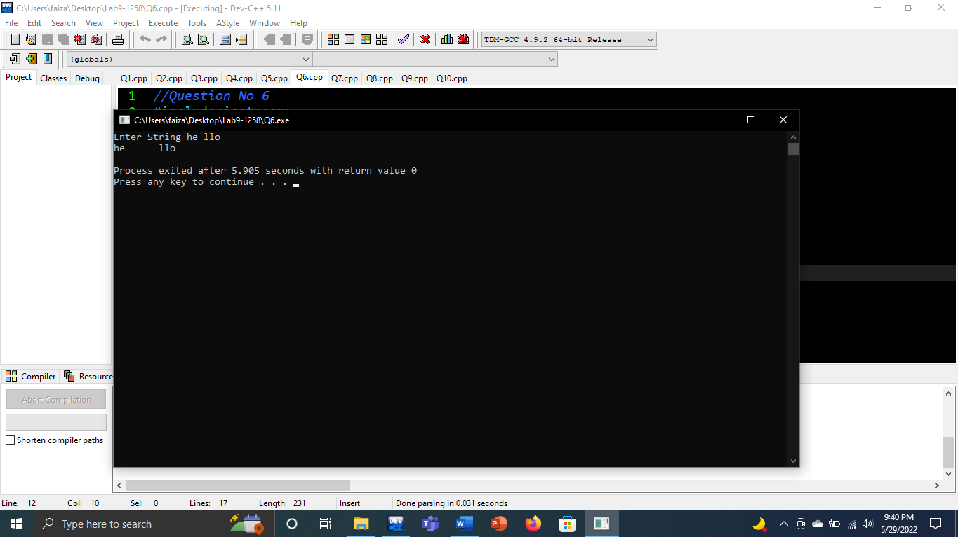

**(Q7)**

#include<iostream>

using namespace std;

int main()

{

char arr[50];

cout<<"Enter Your name ";

int count=0;

gets(arr);

for(int i=0;arr[i]!='\0';i++,count++);

for(int i=count-1;i>=0;i--)

cout<<arr[i];

}

**Output**

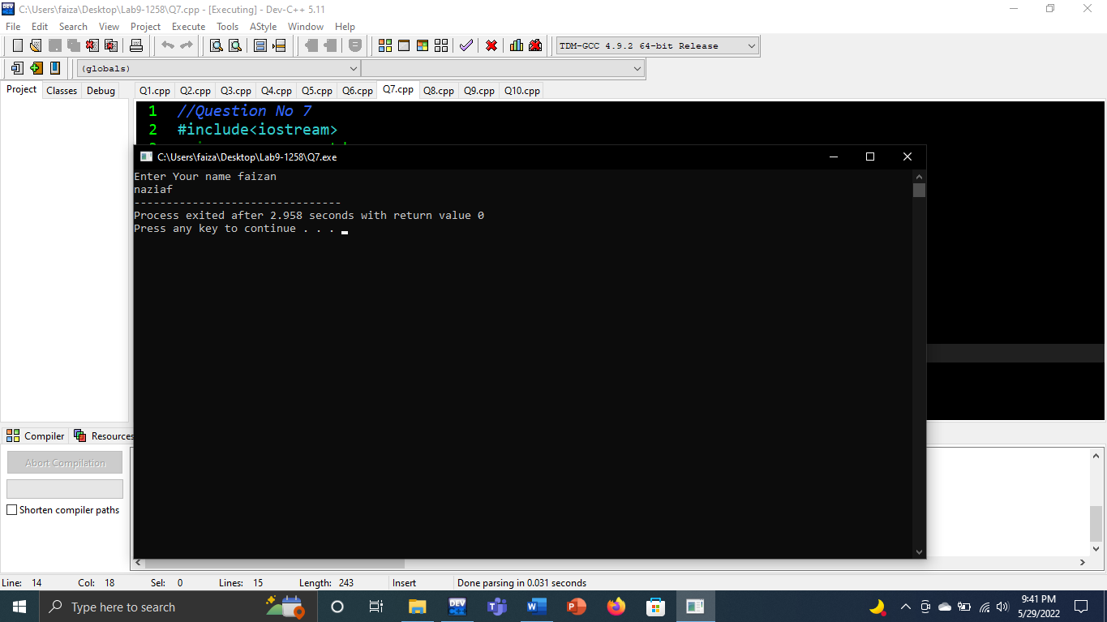

**(Q8)**

#include<iostream>

using namespace std;

int main()

{

char str[100];

cout<<"Enter a string ";

gets(str);

for(int i=0;str[i]!='\0';i++)

{

cout<<str[i]<<endl;

}

}

**Output**

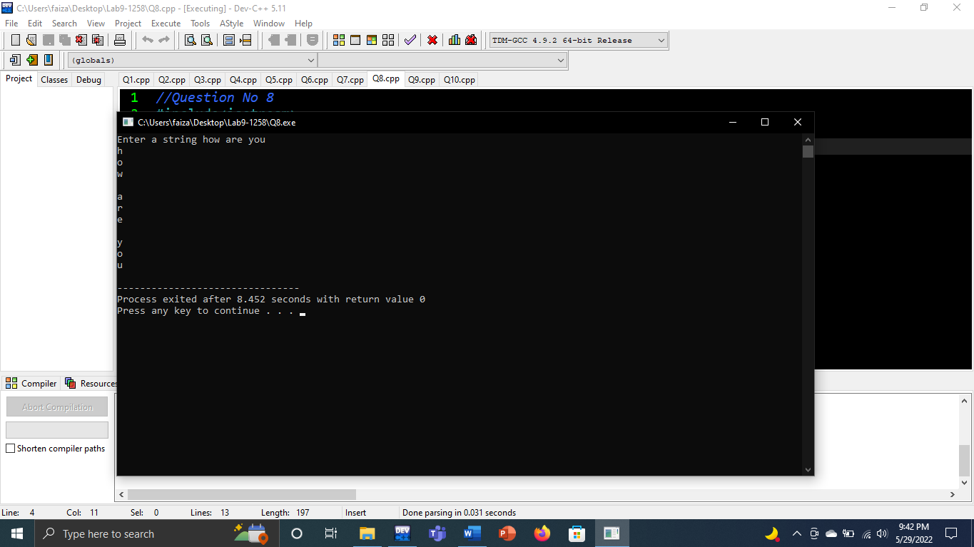

**(Q9)**

#include<iostream>

using namespace std;

int main()

{

char name1[20],name2[20],i,j=0;

cout<<"Enter your first name : ";

gets(name1);

cout<<"Enter your last name : ";

gets(name2);

for(int i=0;name2[i]!='\0';i++)

{

j++;

}

for(int i=0;name2[i]!='\0';i++)

{

name1[j]=name2[i];

j++;

}

name1[j]='\0';

cout<<name1;

}

**Output**

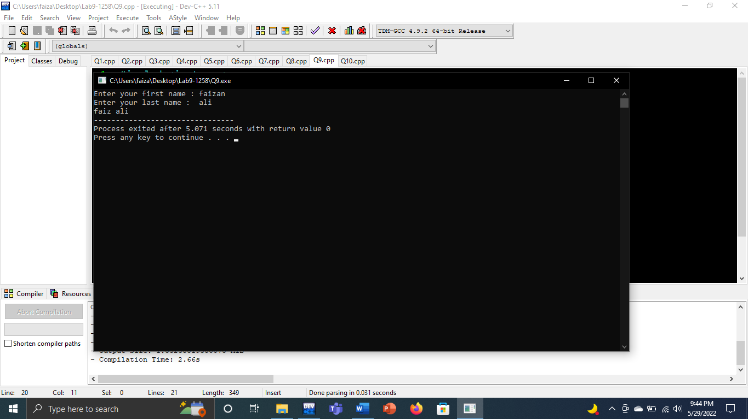

**(Q10)**

#include<iostream>

using namespace std;

int main()

{

char arr[50];

cout<<"Enter Your name ";

gets(arr);

for(int i=0;arr[i]!='\0';i++)

{

if(arr[i]>=97&&arr[i]<=122)

{

arr[i]=arr[i]-32;

}

}

cout<<arr;

}

**Output**

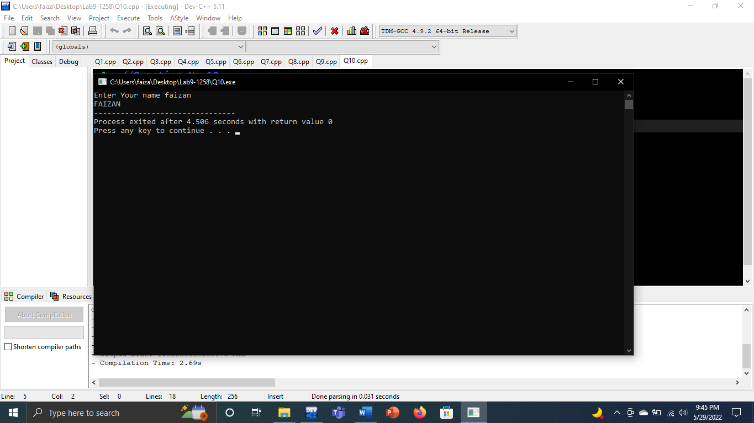

**(Q11)**

#include <iostream>

#include <cstdio>

using namespace std;

void menu();

void input(int[]);

void output(int[]);

void large(int[]);

void small(int[]);

void sortA(int[]);

void sortD(int[]);

void search(int[]);

const int size=10;

bool flag=0;

int main(){

int opt, num[size];

while(true){

menu();

cout<<"Choose Option: ";

cin>>opt;

switch(opt){

case 1: input(num); break;

case 2: output(num); break;

case 3: large(num); break;

case 4: small(num); break;

case 5: sortA(num); break;

case 6: sortD(num); break;

case 7: search(num); break;

default: cout<<" ";

}

if(opt==8){

cout<<"Exited.\n";

break;

}

system("Pause");

system("cls");

}

}

void menu(){

cout<<"\t\t\tMenu\n";

cout<<"\t-------------------------------\n\n";

cout<<"\t1\tInput Array\n\n";

cout<<"\t2\tOutput Array\n\n";

cout<<"\t3\tLargest Element\n\n";

cout<<"\t4\tSmallest Element\n\n";

cout<<"\t5\tSort in Ascending Order\n\n";

cout<<"\t6\tSort in Descending Order\n\n";

cout<<"\t7\tSearch in Array\n\n";

cout<<"\t8\tExit\n";

}

void input(int num[]){

bool flag=1;

cout<<"Enter 10 Numbers: ";

for(int i=0;i<size;i++)

{

cin>>num[i];

}

}

void output(int num[]){

bool flag =1;

for(int i=0; i<size; i++){

cout<<num[i]<<' ';

}

cout<<endl;

}

void large(int num[]){

int max;

max=num[0];

for(int i=1; i<size; i++){

if(max<num[i]){

max=num[i];

}

}

cout<<"Maximum: "<<max<<endl;

}

void small(int num[]){

int min;

min=num[0];

for(int i=1; i<size; i++){

if(min>num[i]){

min=num[i];

}

}

cout<<"Minimum: "<<min<<endl;

}

void sortA(int num[]){

int swape;

for(int j=0; j<size-1;j++){

for(int i=0; i<size-1;i++){

if(num[i]>num[i+1]){

swape=num[i];

num[i]=num[i+1];

num[i+1]=swape;

}

}

}

cout<<"\nAscending: ";

for(int i=0;i<10;i++){

cout<<num[i]<<" ";

}

cout<<endl;

}

void sortD(int num[]){

int swape;

for(int j=0; j<size-1;j++){

for(int i=0; i<=size-1;i++){

if(num[i]<num[i+1]){

swape=num[i];

num[i]=num[i+1];

num[i+1]=swape;

}

}

}

cout<<"\nDescending: ";

for(int i=0;i<10;i++){

cout<<num[i]<<" ";

}

cout<<endl;

}

void search(int num[]){

int found = 0,c;

cout<<"Enter Element to Find: ";

cin>>c;

for(int i=0;i<size;i++){

if(c==num[i]){

found=1;

}

}

if(found==1){

cout<<"Element found in Array.\n";

}

else{

cout<<"Element Not Found in the Array.\n";

}

}

**Output**

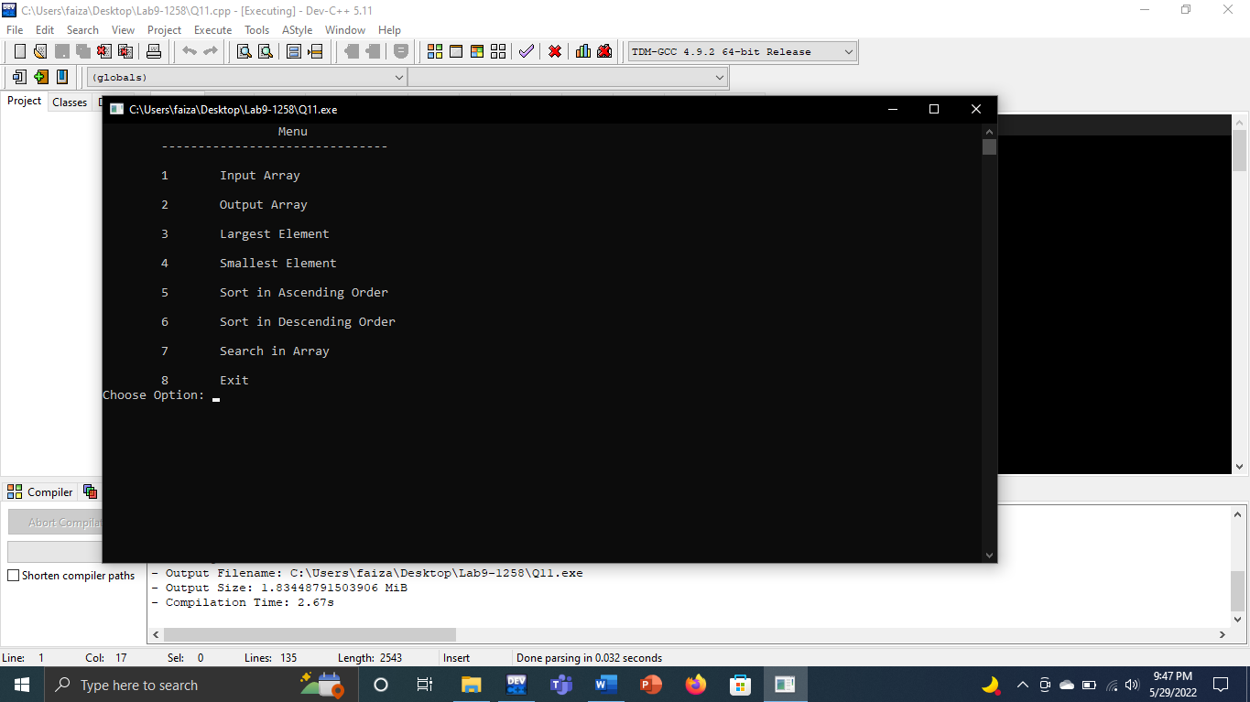

**(Q12)**

#include<iostream>

using namespace std;

void display(int a[],int size)

{

for (int i;i<size;i++)

{

cout<<a[i]<<endl;

}

}

int main()

{

int size=500;

int myarr[size];

for(int i;i<500;i++)

{

myarr[i]=i*2;

}

display(myarr,size);

return 0;

}

**Output**

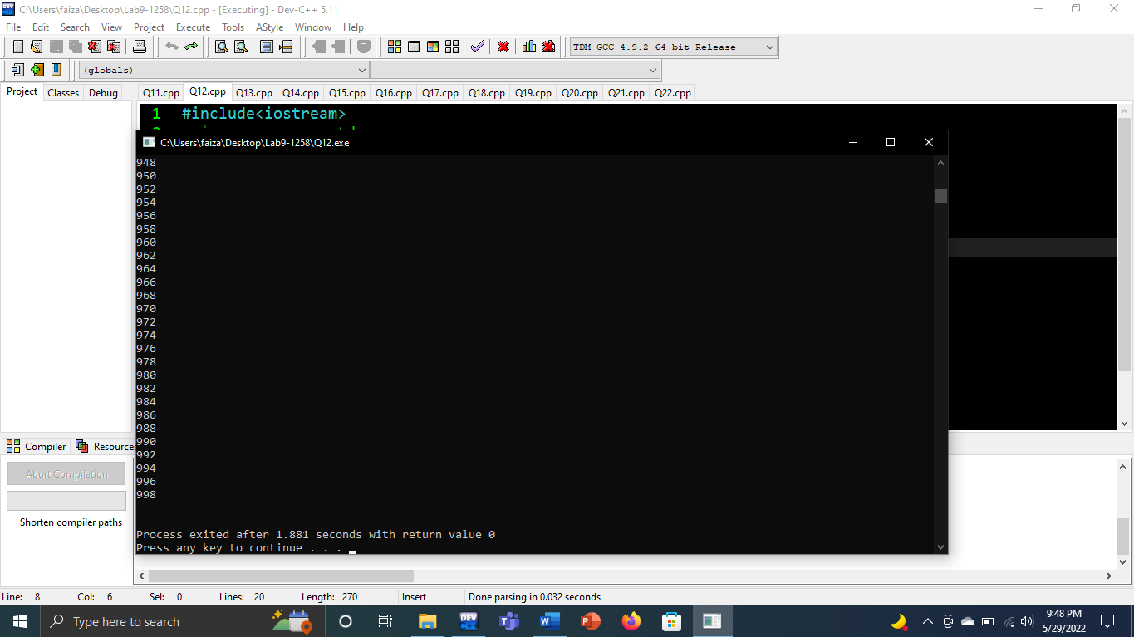

**(Q13)**

#include<iostream>

using namespace std;

void avg(float a, float b, float c)

{

float avg;

avg=(a+b+c)/3;

cout<<"Average is "<<avg;

}

int main()

{

float arr[20]={1.1, 1.2, 1.3, 1.4, 1.5, 1.6, 1.6, 1.7, 1.8, 1.9, 2.0, 2.1, 2.2, 2.3, 2.4, 2.5, 2.6, 2.7, 2.8, 2.9};

avg(arr[0],arr[9],arr[19]);

}

**Output**

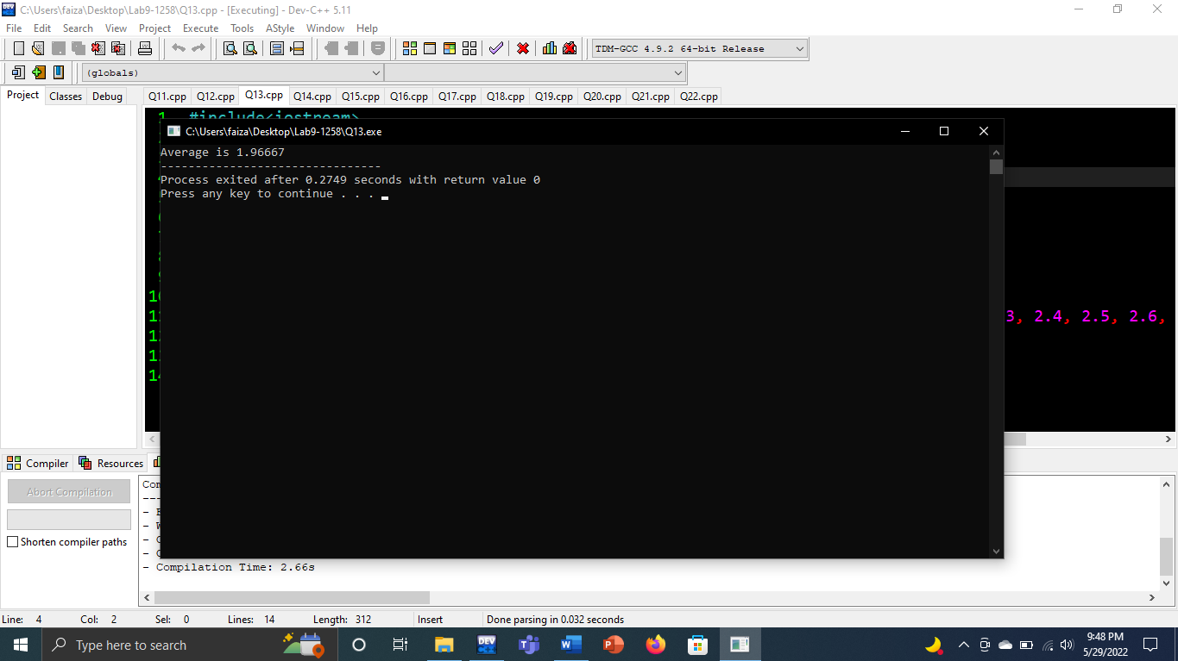

**(Q14)**

#include <iostream>

# include<cstring>

using namespace std;

char palindrome(char a[],char b[] )

{

int found1=0,found2=0;

int length1=strlen(a);

int length2=strlen(b);

for(int i=0;i<length1;i++){

if(a[i]!=a[length1-i-1]){

found1=1;

}

}

for(int j=0;j<length2;j++){

if(b[j]!=b[length2-j-1]){

found2=1;

}

}

if(found1==1){

cout<<a<<" is not palimdrome"<<endl;

}

else{

cout<<a<<" is palindrome "<<endl;

}

if(found2==1){

cout<<b<<" is not palimdrome"<<endl;

}

else{

cout<<b<<" is palindrome "<<endl;

}

}

int main()

{

char string1[200],string2[200];

cout<<"Enter String1 : ";

cin>>string1;

cout<<"Enter String2 : ";

cin>>string2;

palindrome(string1,string2);

return 0;

}

**Output**

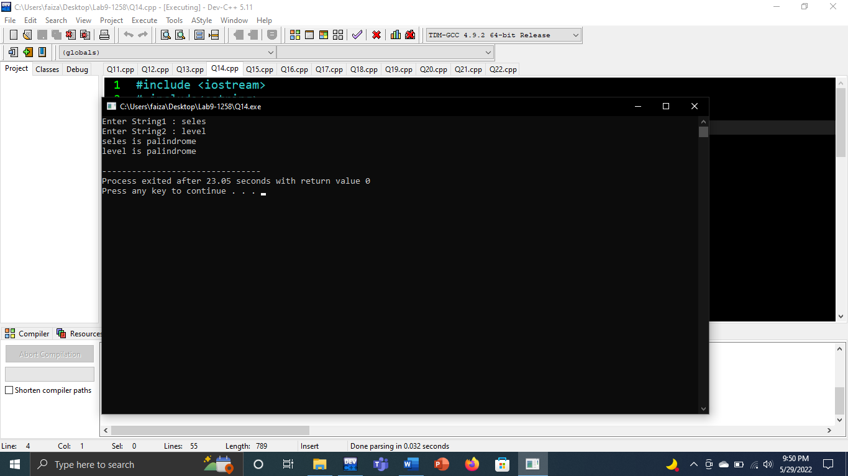

**(Q15)**

#include<iostream>

using namespace std;

int main()

{

int arr[3][5]={1,2,3,4,5,6,7,8,9,10,11,12,13,14,15};

cout<<arr[0][0]<<endl;

cout<<arr[0][1]<<endl;

cout<<arr[0][2]<<endl;

cout<<arr[0][3]<<endl;

cout<<arr[0][4]<<endl;

cout<<arr[1][0]<<endl;

cout<<arr[1][1]<<endl;

cout<<arr[1][2]<<endl;

cout<<arr[1][3]<<endl;

cout<<arr[1][4]<<endl;

cout<<arr[2][0]<<endl;

cout<<arr[2][1]<<endl;

cout<<arr[2][2]<<endl;

cout<<arr[2][3]<<endl;

cout<<arr[2][4]<<endl;

}

**Output**

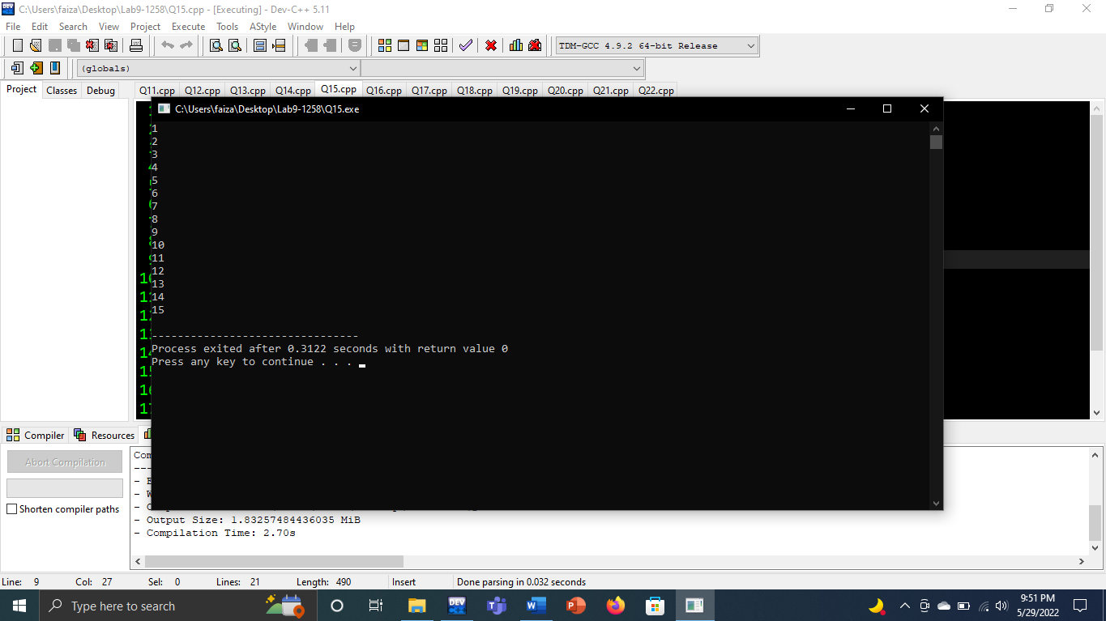

**(Q16)**

#include <iostream>

using namespace std;

int main()

{

int arr[3][2]={{1,2},{6,7},{3,4}};

cout<<"Before Swapping:"<<endl;

cout<<"*********************************"<<endl;

cout<<arr[0][0]<<"\t"<<arr[0][1]<<endl;

cout<<arr[1][0]<<"\t"<<arr[1][1]<<endl;

cout<<arr[2][0]<<"\t"<<arr[2][1]<<endl;

cout<<"After Swapping:"<<endl;

cout<<"*********************************"<<endl;

int temp;

temp=arr[0][1];

arr[0][1]=arr[2][1];

arr[2][1]=temp;

cout<<arr[0][0]<<"\t"<<arr[0][1]<<endl;

cout<<arr[1][0]<<"\t"<<arr[1][1]<<endl;

cout<<arr[2][0]<<"\t"<<arr[2][1]<<endl;

return 0;

}

**Output**

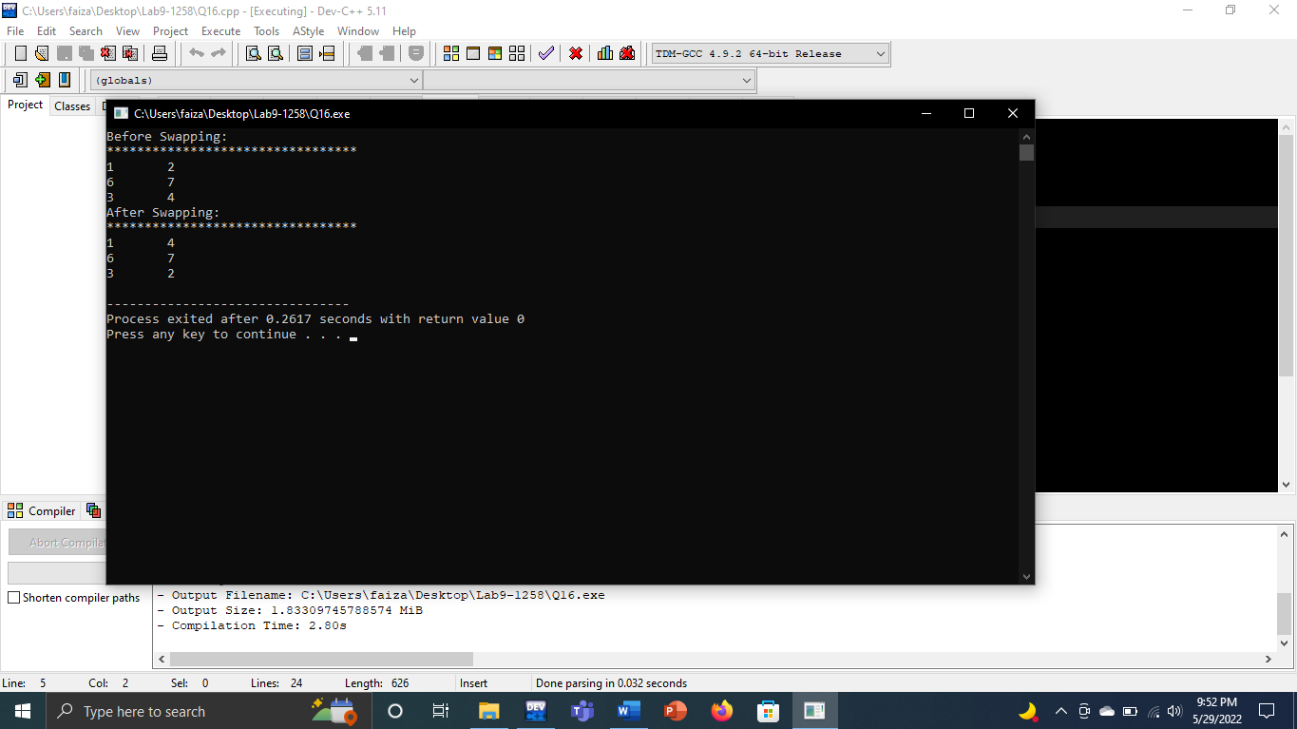

**(Q17)**

#include<iostream>

using namespace std;

int main()

{

int matrix[5][5];

for(int row=0;row<5;row++)

{

for(int col=0;col<5;col++)

{

cout<<"Ener values for matrix"<<endl;

cout<<row<<","<<col<<",\t";

cin>>matrix[row][col];

}

}

cout<<"The values entered for matrix are displayed as"<<endl;

for(int row=0;row<5;row++)

{

for(int col=0;col<5;col++)

{

cout<<"\t"<<matrix[row][col];

}

cout<<endl;

}

}

**Output**

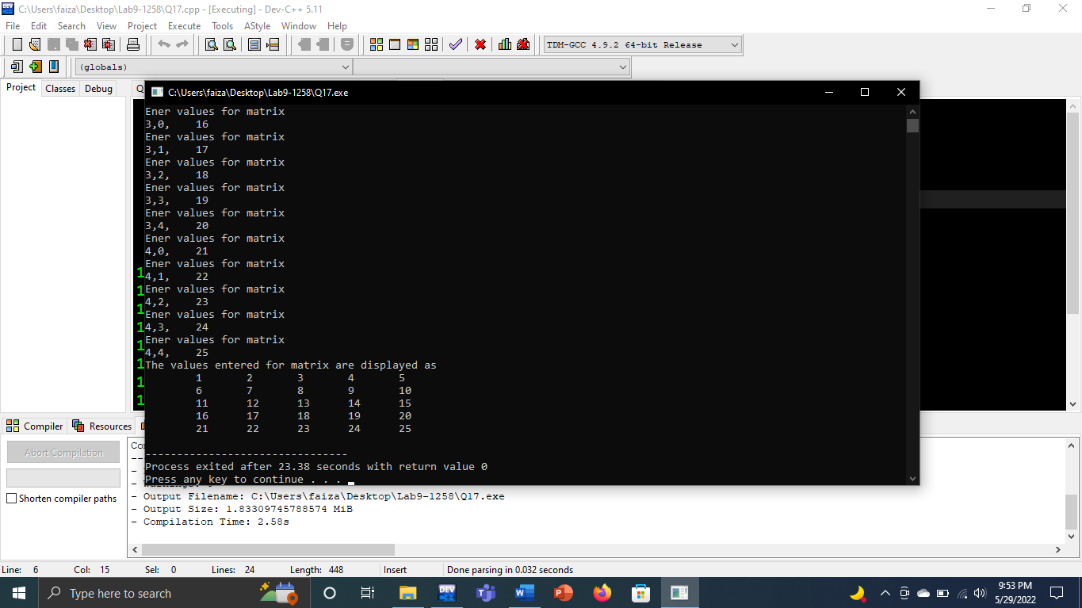

**(Q18)**

#include<iostream>

using namespace std;

int main()

{

int matrix[3][5];

for(int row=0;row<3;row++)

{

for(int col=0;col<5;col++)

{

cout<<"Ener values for matrix"<<endl;

cout<<row<<","<<col<<",\t";

cin>>matrix[row][col];

}

}

cout<<endl;

cout<<"The values entered for matrix are displayed as"<<endl;

for(int row=0;row<3;row++)

{

for(int col=0;col<5;col++)

{

cout<<"\t"<<matrix[row][col]+10;

}

cout<<endl;

}

}

**Output**

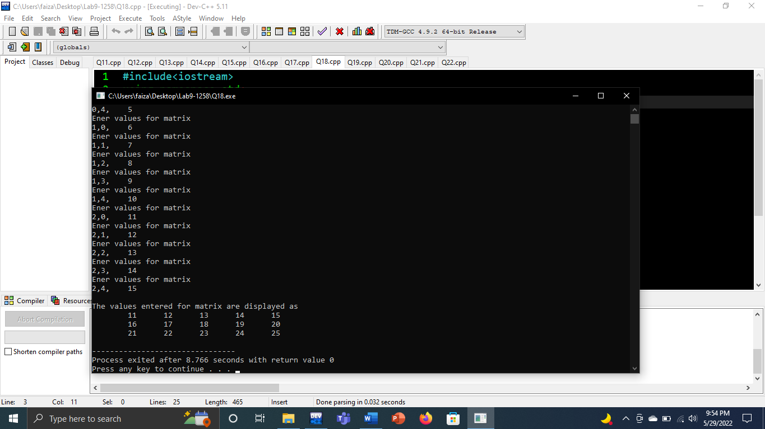

**(Q19)**

#include <iostream>

using namespace std;

int main()

{

int a[4][3];

cout<<"Input Array: "<<endl;

for(int i=0;i<4;i++){

for(int j=0;j<3;j++){

cin>>a[i][j];

}

}

cout<<endl<<endl<<"You Entered: \n";

for(int i=0;i<4;i++){

for(int j=0;j<3;j++){

cout<<a[i][j]<<"\t";

}

cout<<endl;

}

cout<<endl<<endl<<"Output after subtracting 7: \n";

for(int i=0;i<4;i++){

for(int j=0;j<3;j++){

if(i==0||i==3){

cout<<a[i][j]-7<<'\t';

}

else{

cout<<a[i][j]<<'\t';

}

}

cout<<endl;

}

return 0;

}

**Output**

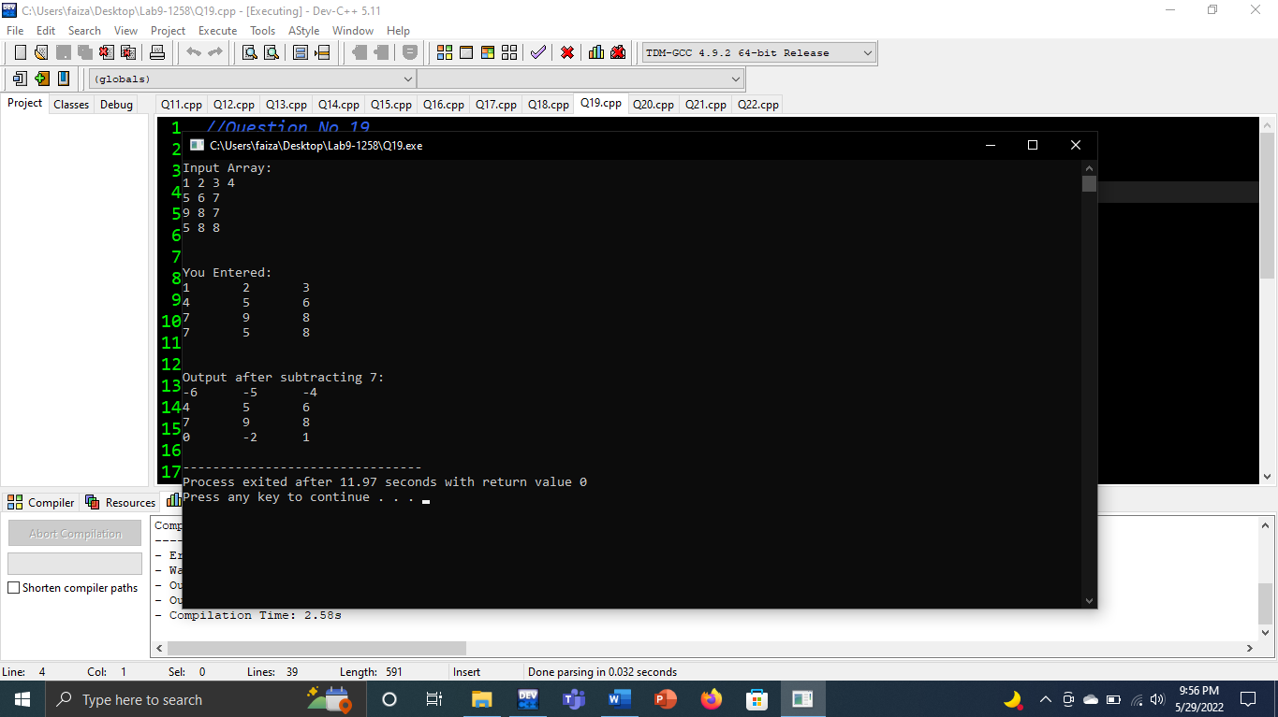

**(Q20)**

#include <iostream>

using namespace std;

int main()

{

int a[4][4],b[4][4];

cout<<"Input first matrix: "<<endl;

for(int i=0;i<4;i++){

for(int j=0;j<4;j++){

cin>>a[i][j];

}

}

cout<<"Input second matrix: "<<endl;

for(int i=0;i<4;i++){

for(int j=0;j<4;j++){

cin>>b[i][j];

}

}

cout<<endl<<endl<<"Output after Subtracting First from Second: \n";

for(int i=0;i<4;i++){

for(int j=0;j<4;j++){

cout<<b[i][j]-a[i][j]<<"\t";

}

cout<<endl;

}

return 0;

}

**Output**

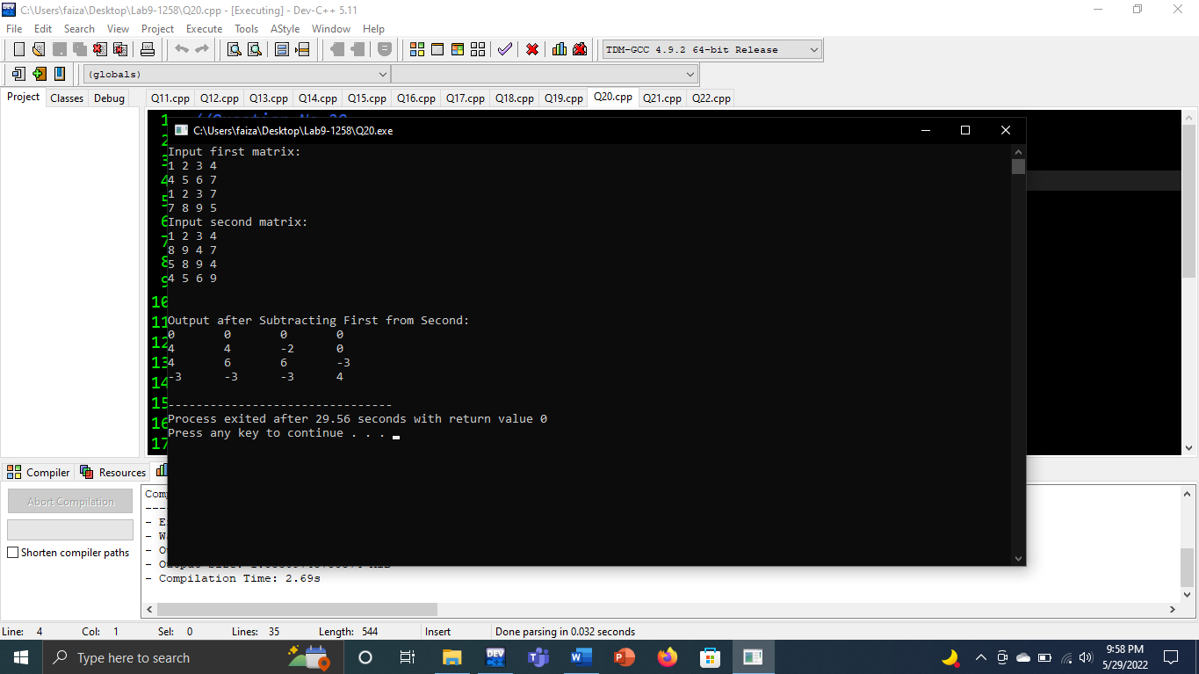

**(Q21)**

#include <iostream>

using namespace std;

int main()

{

int a[5][5];

cout<<"Input first matrix: "<<endl;

for(int i=0;i<5;i++){

for(int j=0;j<5;j++){

cin>>a[i][j];

}

}

cout<<"Diagonal matrix: "<<endl;

for(int i=0;i<5;i++){

for(int j=0;j<5;j++){

if(i==j){

cout<<a[i][j]<<'\t';

}

else{

cout<<0<<"\t";

}

}

cout<<endl;

}

return 0;

}

**Output**

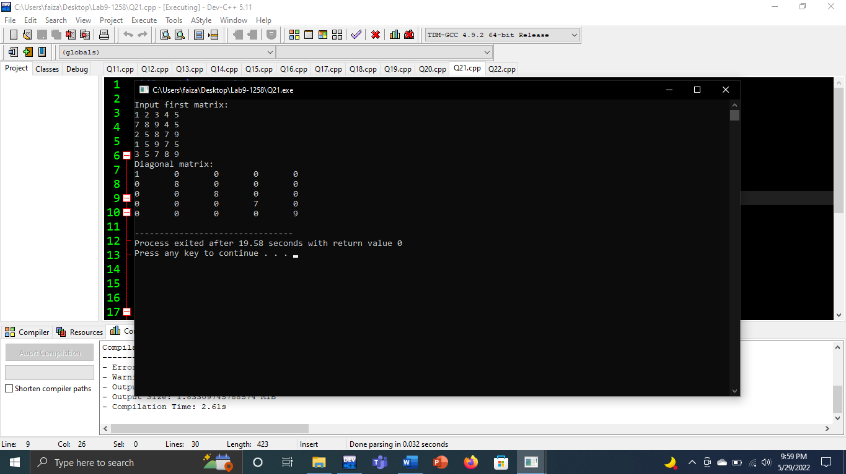

**(Q22)**

#include <iostream>

using namespace std;

int main()

{

int a[5][5],b[5][5];

cout<<"Input matrix: "<<endl;

for(int i=0;i<5;i++){

for(int j=0;j<5;j++){

cin>>a[i][j];

}

}

for(int i=0;i<5;i++){

for(int j=0;j<5;j++){

b[i][j]=a[j][i];

}

}

cout<<endl<<endl<<"transpose of matrix: "<<endl;

for(int i=0;i<5;i++){

for(int j=0;j<5;j++){

cout<<b[i][j]<<"\t";

}

cout<<endl;

}

return 0;

}

**Output**

